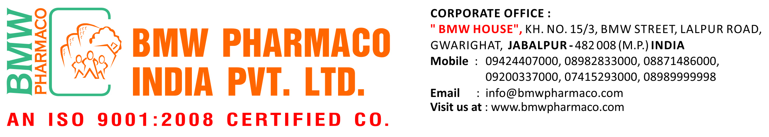

PRE INTERVIEW DETAILS

1. Applied for the post of:

2. Name: 3.Father’s Name:

3. Date of Birth 4. Age :

5. Contact: Mob. 6.Email:

7. Sex :( M / F ) 8. Status :( Married / Single )

9. Present Address: 10. Permanent Address:

10. Family Profile (Occupation / Income):
/
/
Father: Mother:
/
/
Brother: Sister:
Spouse: Children:
/
/

11. Experience:

S.No | Name of the Company & Place | HQ | Designation | Period |  | Salary Drawn | Reason for relieving
 |  |  |  | From - To |  | Salary Drawn | Reason for relieving

12. Education:

Exam’s Name | Board / University | Year | Percentage | Subject
SSC
School
HSC
School
Graduation
PG
Other’s

11. Own Conveyance: (Vehicle)

12. Languages Known:

13. Present Salary (Nett): Expected Salary:

14. Strength:

Weakness:

15.Why do think that you are eligible for the post?

16.Work Experience in Pharmaceuticals Marketing & Achievements.:

References:

A.)Name. Address & Contact No.

B.)Name Address & Contact No.

Date: ………..……… Signature:

For Office Use: ……………………………………………………………………………………………..............
……………..…………………………………………………………………………….……………………………………………………………………………………………………………………………….…………………….
……………………………………………………………………………………………………………..…………

